This is the first sample on my blog which is not written by me. Another member of the API team put this one together based on some customer requests.
The Parts List Tab is a file tab that will show any associated Item BOM data. The idea is to make navigation easier because you are not constantly switching back and forth between File and Item views.
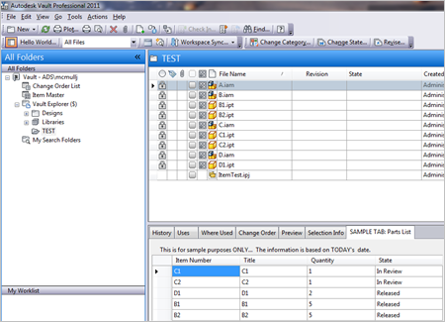
(click image for full view)
Requirements:
Vault Workgroup/Collaboration/Professional 2011
Click here to download the application
Click here to download the source code
To Use:
Download the application and run the installer.

